Concentrations, loads, and associatedjatrends in nutrients entering the Sacramento-San Joaquin Delta, Priority Ecosystems Project

### By Dina Saleh and Joseph Domagalski

# Introduction

The Sacramento-San Joaquin Delta (the Delta) system is the largest estuary on the west

coast of North America covering an area of about 2,984 km2. The Delta is also a point of transfer of significant amounts of freshwater to cities and agricultural regions (Templin and Cherry, 1997, Saleh and Domagalski, 2015). About 2,024 km2 of the Delta is agricultural land and home to 230 species of bird, 45 species of mammals, and 52 species of fish (Saleh et al., 2003; CA.Gov Delta Protection Commission, <http://www.delta.ca.gov/rec_economic.htm>). High nutrient concentrations in the Delta contribute to nutrient-related problems in drinking water systems as wells as to water increased biological activities related to production of blue green algae and invasive aquatic macrophytes. Statistical analyses and water quality modeling has identified treated wastewater effluent from publicly owned treatment works (POTWs) as one of the main sources of total nitrogen (TN) and phosphorus (TP) to the Delta (Saleh and Domagalski 2015, Domagalski and Saleh, 2015, Jassby and others, 2002, and Novick and others 2015). In 2018 the Delta Science Program (DSP) and the San Francisco Estuary Institute-Aquatic Science Center (SFEI-ASC) developed a plan for improvements and upgrades at four major POTWs (Krich_Briton, A,2017 memo, Krich_Briton at al., 2012) to decrease future nutrients concentrations and loads transported to the Delta (fig 1). Three of these facilities are located on the San Joaquin River; the Modesto Water Quality Control Facility (WQCF) and the Turlock Regional Water Quality Control Facility (QCF), where upgrades involve diverting tertiary discharge from these two facilities away from the San Joaquin River to the Delta Mendota Canal to decrease the amount of effluent entering the San Joaquin River from upstream locations. The third facility on the San Joaquin River is the Stockton Regional (Stockton) Wastewater Control Facility (RWCF) where plans are set to upgrade the facility to include denitrifications and or other forms of treatment to increase water quality from this facility to the Delta. The Sacramento Regional County Sanitation (Regional San) District's Wastewater Treatment Plant (WWTP) is the only facility upgraded on the Sacramento River and plans include enhanced biological nutrient removal, followed by chemical phosphorus removal with tertiary clarification, tertiary filtration and ultraviolet (UV) disinfection (Yost 2011). These upgrades are expected to significantly decrease nutrients load to the Sacramento and San Joaquin River Delta to about 99% annual decrease in ammonium (NH4), and 75% annual decrease in Total Nitrogen (TN) concentrations (Krich_Briton, A,2017 memo).

To better understand the future effects of these planed changes on nutrient availability and transport to the Delta it is important to evaluate historical nutrient loads and trends in the Sacramento and San Joaquin Rivers upstream of the two main WWTP facilities, the Regional San and Stockton facilities respectfully (fig1). Various forms of nitrogen and phosphorus data from two monitoring sites, the Sacramento River at Freeport and San Joaquin River at Vernalis were modeled to evaluate concentrations, loads, and associated trends to the Delta for the 1975 to 2019 period. Data from these two sites will be used to evaluate historical nutrients specific sources, spatial distribution, and transport of nutrients to the Delta from the upstream portion of the two watersheds. This time period will capture extrema weather conditions transitioning from wet years (1997) through drought years (2012-2016). Trend estimation will include total nitrogen (TN), nitrate (NO3), ammonium (NH4), orthophosphate (OP) and total phosphorus (TP) allowing managers to understand the watershed contribution of various forms of bioavailable nutrients. Results from this analyses will provide increased understanding of the relative influences of the facility update on water-quality in the Delta.

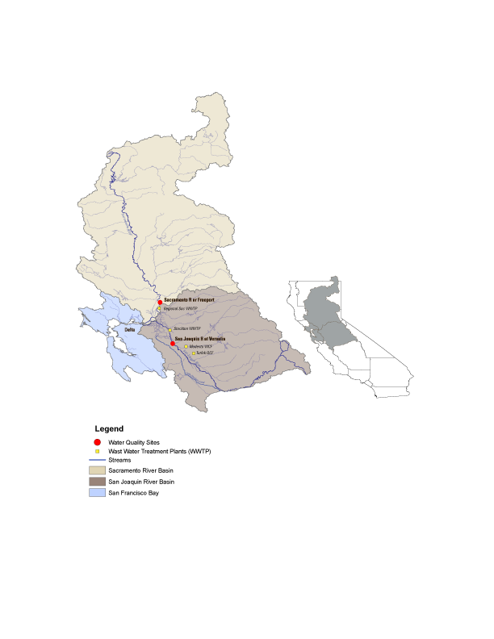

# **Location and Data Sources**

The Delta system is the largest estuary on the west coast of North America consisting of about 4,160 km2 of which the Delta makes up about 2,984 km2.The Sacramento and San Joaquin Rivers deliver freshwater to the Delta with about 84% coming from the Sacramento River, 13% coming from the San Joaquin River, and 3% from other smaller rivers (Jassby and Cloern, 2000, Saleh and Domagalski, 2015). The Sacramento and San Joaquin Rivers are the two largest River in California delivering an average of 650 cms and 120 cms of water respectfully to the Delta annually. Both rives systems contain many diversions and impoundments designed to provide flood protection to downstream cities as well as to divert water used for irrigation in agricultural areas with in the central valley (Kratzer at al, 2011). In the Sacramento watershed and upstream from Freeport water is diverted during high winter and spring flows to the Sutter Bypass and the Yolo Bypass, around the Freeport gage and returned to the Sacramento River downstream of Freeport into the Delta. Nutrients enter the Delta primarily through the Sacramento and San Joaquin Rivers and from municipal wastewater treatment plant (WWTP) inputs. The Reginal Sac WWTP is located about 10 miles downstream from the Sacramento River near Freeport site (fig1). Sac Reginal is designed to release about 116 Million Gallons per Day (MGD) of secondary treated effluent to the Sacramento River, with nutrient concentrations averaging about 13,594 kg/ day Ammonium (NH4), 14,818 kg/day Total Nitrogen (TN), and 999 kg/day Total Phosphorus (TP) (Yost, 2011). The Stockton WWTP is located about 50 miles downstream from the Vernalis site. Stockton WWTP is designed to release about 23 MGD of tertiary treated with nitrification effluent to the San Joaquin River, with lower nutrient concentrations averaging about 114 kg/ day Ammonium (NH4), 1,579 kg/day Total Nitrogen (TN), and 89.9 kg/day Total Phosphorus (TP) (Yost, 2011).

Concentration data for nitrate, ammonium, Kjeldahl Nitrogen, orthophosphorus, and total phosphorus (total nitrogen is the sum of nitrate and Kjeldahl Nitrogen) for the study were obtained from two USGS stream gages Sacramento River near Freeport (Freeport, 11447650)

and the San Joaquin River at Vernalis (Vernalis, (11303500) over the 1970-2019 period. All the discharge data and most of the water quality data was obtained from U.S. Geological Survey National Water Inventory System (NWIS) other water quality data were obtained from published data set associated with Kratzer et al. (2011). These two sites selected for this study were sampled frequently (have more than 200 samples) over the 1970-2019 period and have a continuance record of streamflow data concurrent with the water quality records at these sites.

# **Methods**

Nutrient concentrations, loads, trends and sources transported to the Delta for the 1970-2019 period were evaluated using the Weighted Regressions on Time, Discharge, and Season (WRTDS) and the SPAtially Referenced Regressions On Watershed attributes (SPARROW) models (Hirsch et al. 2010, Preston et al., 2009, 2011b). The WRTDS model has been implemented within the R package, known as the Exploration and Graphics for RivEr Trends (EGRET) model. WRTDS was used to estimate annual flux and trends in nutrient concentrations at Freeport and Vernalis for the 1970-2019 period (Hirsch at al. bootstrap paper). WRTDS evaluates a concentration-discharge relationship based on time, discharge and season by re-evaluating coefficients for each day of estimation. The estimated concentration is a product of the fallowing equation:

In(*Cij*)=*β0*+ *β1Tij* + *β2* In(*Qij*)+ *β*3 sin(2π*Tij*) + *β*4 cos(2π*Tij*) + ε*ij*  (1)

Where for a specific day *i* and year *j*:

*C*; is the concentration (in mg/L), *Q*; is the mean daily discharge (in m3/s), T; is the time in decimal years, β; are fitted coefficients, and ε is the unexplained variation. To estimate a continuance concentration, a unique regression model is fitted to each sampled concentration, this regression is a product time (T), Discharge log(Q), and season of the year (Hirsch et al. 2010). Within an annual time period, there are great variation in historical streamflow measurement at any given site over the period of the record. Although these variations are real and might be related in extreme weather conditions (extreme wet or drought years); these measurement will have great influence on the WRTDS historically simulated nutrient concentration and trends within the 1970-2019 period. To deal with discharge variations the Flow-Normalized-Concentrations (FNC) approach is used in WRTDS (Hirsch et al. 2010). The FNC for day *i* and year *j* is defined as (equation2):

$C_{ij}= \int_{0}^{∞}{w\left(Q, T_{ij}\right).g_{ij}\left(Q\right)dQ}$ (2)

Where: C*ij* is the flow-normalized-concentration for day *i* and year *j*, g*ij*(Q) is the probability density function of discharge (Q) for day *i* of year *j*, and w(Q,Tij) is a smooth continuous function of two variables, discharge (Q) in m3/s, and time (T) value for day *i* and year *j*. WRTDS uses weighted regression approach to estimate *w*, g(Q) is estimated with the flow-normalization approach with the assumption that discharge is stationary for any day *i* in a year *j* over the period of record (Hirsch et al. 2010).

The flow normalized-concentrations were used to compute a flux estimation using the fallowing equation:

$f^{^ }=86.40 c^{^}Q$ (3)

Where, $f^{^ }$ is the estimated daily flux, in kg/day, $c^{^}$ is the estimated daily concentration in mg/l, and $Q$ is daily discharge in m3/sec, 86.40 is the unit conversion factor. These estimations were then averaged and evaluated over an annual time series.

Trends in flow normalized concentrations and fluxes were evaluated over the 1970-2019 period using a bootstrap method as part of the EGRETci (Exploration and Graphics for RivEr Trends, confidence intervals) package developed in WRTDS (Hirsch et al. 2015). The EGRETci method applies a bootstrapping test using Monte Carlo simulations to estimate the probability of detecting a trend. The model runs 100 bootstrapping test iterations over a 200-day bootstrapping window for the 1970-2019 duration period. Output from the EGRETci test includes a p-value statistics, however trend uncertainty is expressed in terms of an estimate of trend likelihood representing the probability of increasing or decreasing of trends within 100 bootstrapping iterations (Hirsch et al. 2015). The trend likelihood terminology is divided into 3 categories (table1). Within any trend direction; a “Highly Likely” trend would mean that at there is at least 95 out of a 100 chance that there is a trend in that direction, a “Very Likely” trend means that there are 90 to 95 chances of a 100 that the trend would be in a specific direction, and finally a “Likely” trend would mean that there is a 90 to 66 chances of a 100 that there is a trend in a that direction. Along with the likelihood and the direction of trend for each constituent, EGRETci output will also provide an estimated change value for concentrations and loads in mg/l and kg/year respectively.

SPARROW (2012) modeling was used to identify sources of total nitrogen and total phosphorus to the Sacramento and San Joaquin Rivers. The SPARROW model uses a hybrid statistical and

process-based approach that relates nutrient loads to upstream sources, and watershed characteristics using a nonlinear least squares (NLLS) multiple regression. SPARROW includes

nonconservative transport, mass-balance constraints, and water flow paths referenced to the digital a stream network, National Hydrography Dataset Plus (NHD-Plus) Version 2, which defines topography, streams characteristics, and reservoirs inputs for the SPARROW model.

The SPARROW model includes three types of parameters to provide a prediction on fluxes leaving catchments: sources, land-to-water delivery variables, and instream loss. Water-quality predictors in the model are developed as functions of both reach and land surface attributes and include quantities describing contaminant sources (point and nonpoint) as well as factors associated with rates of material transport through the watershed. Details on the theoretical development of the SPARROW model are provided by Alexander et al. (2008) and Schwarz et al. (2006).

# **Results**

## **Trends in Discharge**

Statistical analyses were used to evaluate trends in daily discharge over the 1970-2019 period for the Sacramento River near Freeport and the San Joaquin river at Vernalis. Results show that there is a decreasing trend in all four annual statistics for both sites (fig2, and fig3). however, these trends are only statistically significant for annual minimum daily discharges at the Sacramento River near Freeport with a p-value of 0.052 and a decreasing slope of 0.76% per year. This is also reflected in the Quantile-Kendall plot (fig4). The plot shows that at both sites and over the 365 days of the year, there is no statistically significant trend in all parts of the flow duration curve (Hirsch, 2015).

Discharge measurements at the Sacramento River near Freeport and the San Joaquin river at Vernalis varies significantly and are consistent with extreme weather condition during the 1970-2019 period. During extreme wet condition in 1997, maximum discharge measurement at the Sacramento River near Freeport and the San Joaquin river at Vernalis reach to 3200 m3/sec, and 1537 m3/sec respectively. Discharges decreased dramatically during the reported drought period of 2012-2016 (Western Regional Climate Center <http://www.wrcc.dri.edu/cg-bin/cliMONtpre.pl?ca7630>) where average measured discharge at the two sites were about 175 m3/s at Sacramento River near Freeport, and about 9 m3/sec at San Joaquin river at Vernalis.

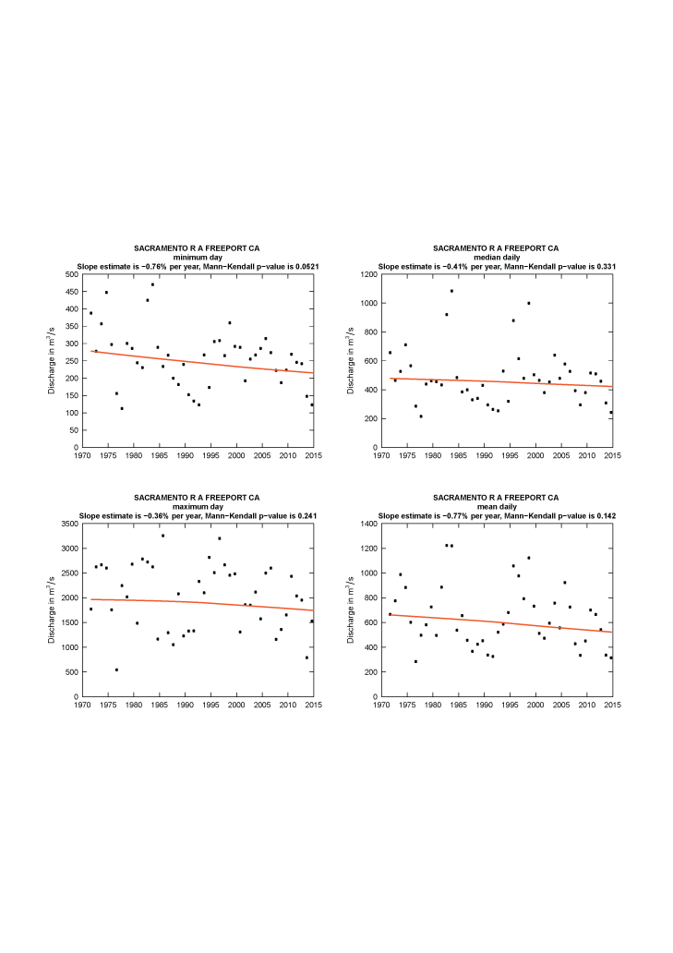

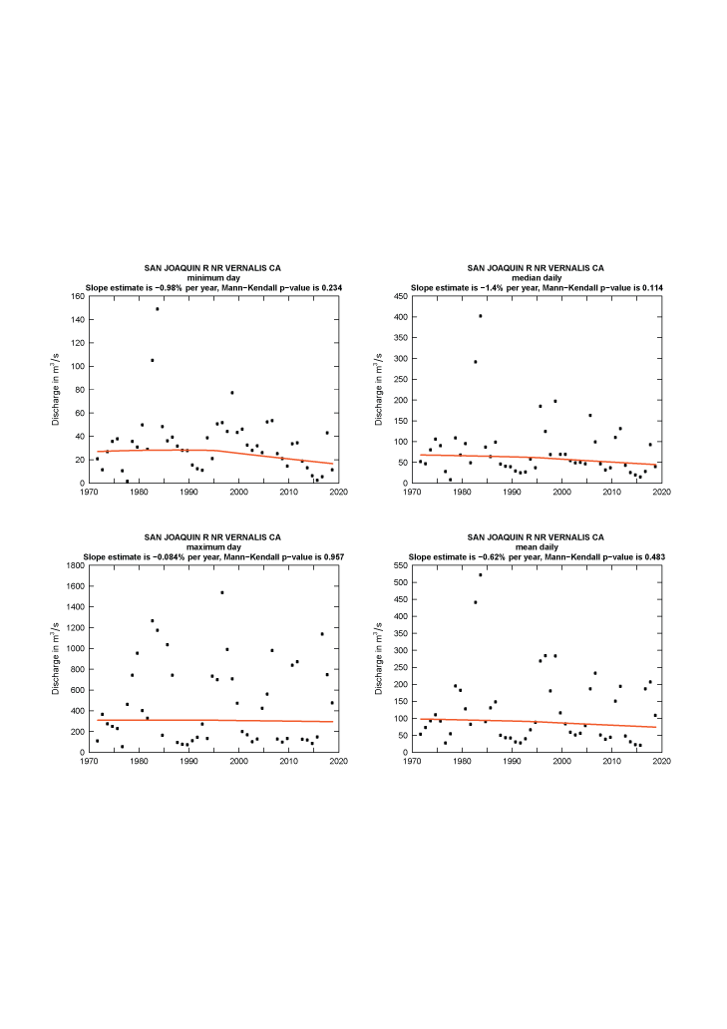

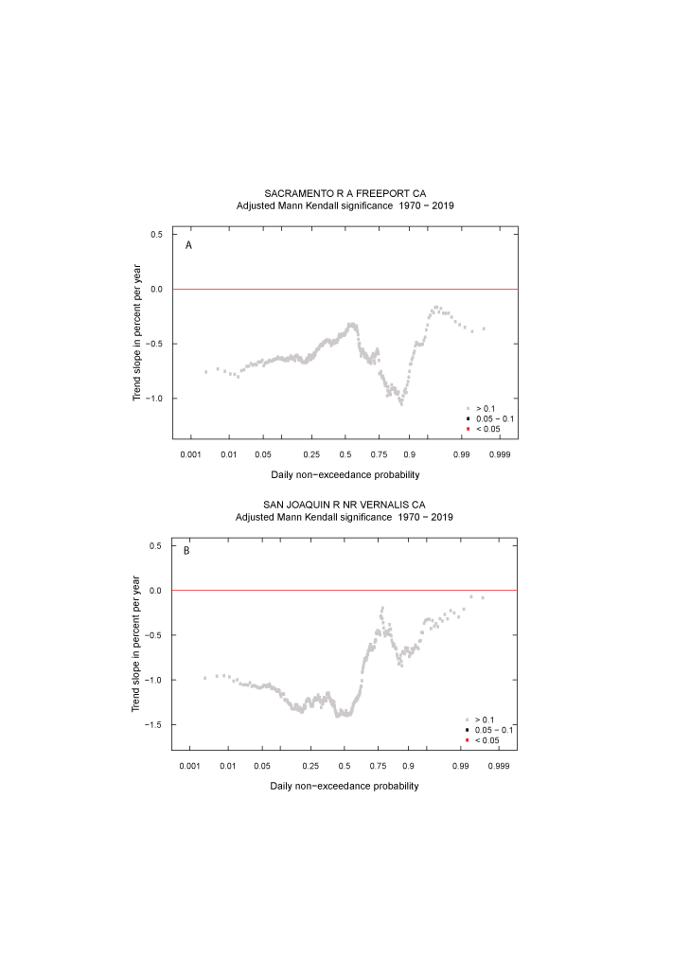

## **Nutrient Concentrations, Fluxes, and Trends:**

Statistical analyses and modeling were used to evaluate nutrient concentrations and trends to the Delta throughout the 1970-2019 period these include:

### SPARROW modeling:

The newly developed 2012 SPARROW model was used to quantify the amount of TN and TP delivered to the Delta and to identify major sources of TN and TP both on a watershed scale and on cumulative scale along the course of the Sacramento River and the San Joaquin River. The model estimated more than 6.8 million kg/year and about 3 million kg/year of total nitrogen (TN) is delivered to the Delta from the Sacramento and San Joaquin Rivers respectively. Within the Sacramento River watershed, the model identified major sources of total nitrogen as; 40% from fertilizer and manure applied to agricultural areas within the central valley (fig 5), 32% from atmospheric deposition, 14% from point sources from waste water treatment facilities, 8% from scrub and grass land, and 6% and urban runoff around the main cities (fig 5). Within the San Joaquin River watershed, the model identified major sources of total nitrogen as; 65% from fertilizer and manure, 17% from atmospheric deposition, 10% from point sources from waste water treatment facilities, 5% from scrub and grass land, and 3% and urban runoff (fig 5).

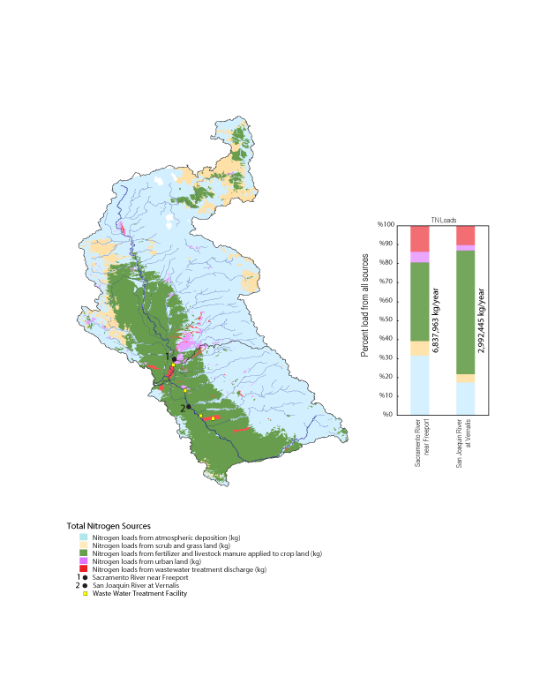

Along the course 600 km of the Sacramento River, sources of TN vary. In the headwaters atmospheric deposition is the main source of TN as the water moves through the central valley sources change and loads from fertilizer and livestock manure applications increase drastically at about 150 km from the mouth due to increased discharges from Colusa Basin Drain and the Feather River that deliver water from agricultural land. Downstream of the Sacramento River near Freeport site, at 70 km from the mouth, TN from point sources increase due to discharges from Sac Regional wastewater treatment plan (Fig 6A). Along the course of 500 km San Joaquin River the main source of TN loads is from fertilizer and livestock manure applied to agricultural lands. TN loads from point sources increase at about 150 km from the mouth due to increased discharge from waste water treatment facilities in the cities of Turlock and Modesto and increased at about 66 km from the mouth due to discharge from the Stockton waste water treatment plant (fig 6B)

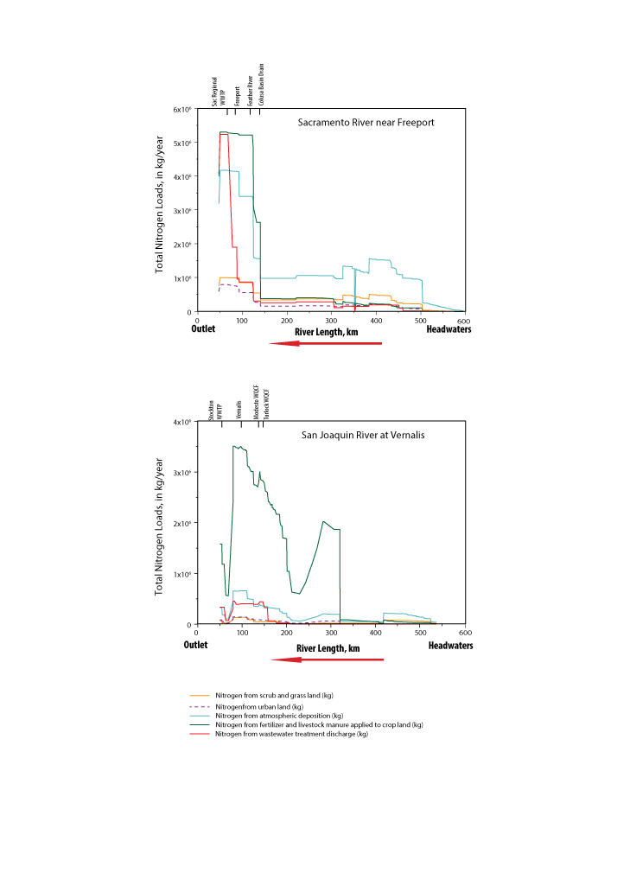

Results from the SPARROW model show 1.5 million kg/year and about 0.5 million kg/year of total phosphorus (TP) is delivered to the Delta from the Sacramento and San Joaquin Rivers respectively. Major sources of TP in the Sacramento River watershed were 46% from agricultural activities (from fertilizer and manure applications to agricultural lands within the central valley), 35% from wastewater treatment facilities discharges, 13% from geologic phosphorus from the stream channel and upland areas, and 7% from urban runoff around the main cities (fig 7). In the San Joaquin river watershed, most TP loads (73%) comes from agricultural activities from fertilizer and manure applications, 20% from wastewater treatment facilities discharges, 6% from geologic phosphorus from the stream channel and upland areas, and 2% from urban runoff (fig 7). Along the course of the Sacramento River, agricultural activity (from applied fertilizer and manure) account from most of the TP loads from the headwaters through the central valley till about 70 km from the mouth when discharges from Sac Regional wastewater treatment plan cause a great increase in TP loads from point sources discharges (fig 8A). In the San Joaquin river agricultural activity also account for most of the TP loads along the course of the river. TP loads from point sources start to increase with the increase of discharges from waste water facilities, from Turlock and Modesto at 150 km and Stockton at 66km (fig 8B).

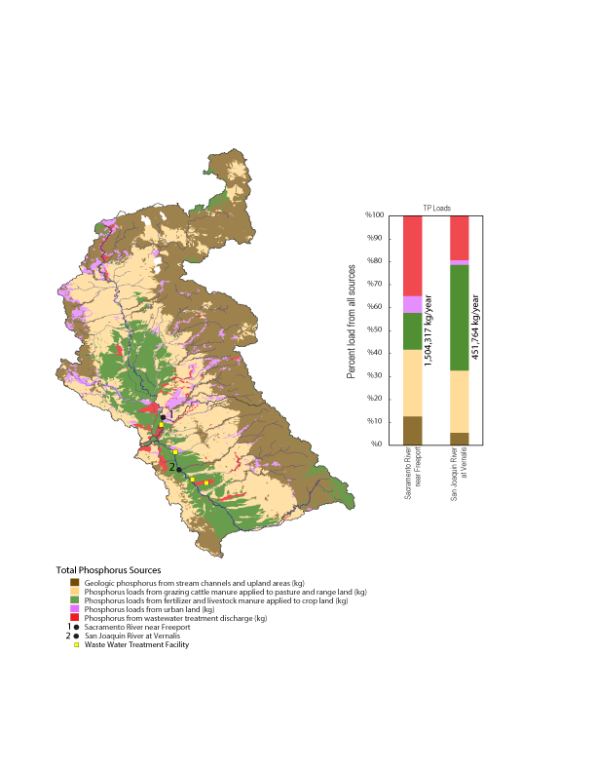

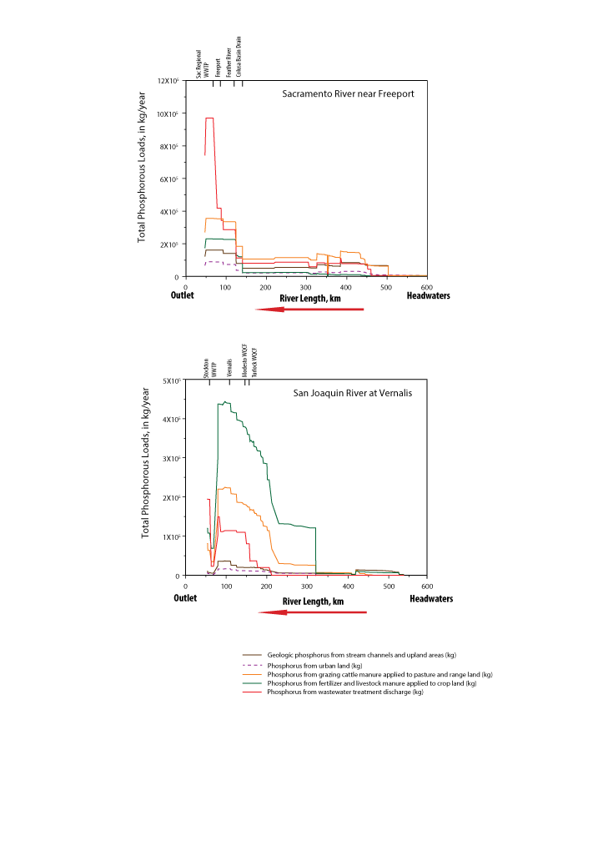

### EGRET and the WRTDS model:

Estimated flow-normalized concentrations and fluxes for nitrogen forms; Nitrate (NO3), Ammonium (NH4), Total Kjeldahl (TKN), Orthophosphate (OP), and Total Phosphorus (TP), over the 1970-2019 period were estimated using the WRTDS model for the Sacramento River near Freeport and the San Joaquin River at Vernalis.

#### **Sacramento River near Freeport:**

Results of the WRTDS model are shown in figure 9, flow-normalized NO3 concentrations and loads fallow a similar pattern throughout the 1970-2019 period (fig 9a, and 9b). These patterns are effected greatly by flow variations reflected by extreme weather conditions of wet and dry years. Concentrations and loads increase in the earlier time period (1975 to 1983) followed by a slight decrease 1983, associated to extreme wet conditions and dilution of concentration. Concentrations increased slightly in late 1980s and NO3 concentrations and loads reach their highest estimates in 1988 (0.15 mg/L, and 3.15 million kg/Year respectively). Concentrations declined in the early 1990s and remained throughout the mid-1990s and early 2000s and decreased slightly during the 2013-2015 drought period. Results from the EGRITci test show high variation in estimated concentrations and loads reflected in the relatively wide 90% confidence band throughout 1970-2019 period (figs 9a and 9b). However, this variation is more significant in load estimations where most of the estimated observations fall outside the 90% band. Results of the EGRITci test also show a weak “likely” increase in concentration (about 0.02 mg/l) and loads (about 0.48 million kg/Year) over the 1970-2019 period (Table 1). A Mann-Whitney-Wilcoxon Rank Sum test was used to compare NO3 concentrations between the early decade 1975-1985 and the recent decade 2009-2019 on a monthly time scale (fig 10a). In the early decade NO3 concentrations were highest in the winter, this corresponds with extreme weather conditions 1983 wet year. In contrast in the recent decade, NO3 concentrations are low in the winter and increase during the summer reaching its highest value in June. The NO3 median concentrations difference between the early and recent decade are significantly decreasing in the winter (October through March) and significantly increasing during the summer months (May through August) Figure 10c. Hover median concentrations difference between the early and recent decade are not significant in the months of April and September. This is reflected in Figure 10c, where the vertical line crosses the 90% confidence for the median concentration difference between the two decades.

Estimated annual concentrations and loads for NH4 show a different pattern than that of NO3 (Figs 10c and 10d). Results show an extreme decline in both concentrations and loads during the initial modeling period (in 1979, with a record high of concentrations and loads estimated at 0.2 mg/l, and 2.7 million kg/year respectively) fallowed by a continues gradual decline in concentrations and loads to 2019. Variation in estimated NH4 concentrations are low reflected in the narrow 90% confidence band (figs 9c and 9d). Over all trends in NH4 concentrations and loads were “highly likely” decreasing over the 1970-2019 period to about 0.17 mg/l in concentration and 2.45 million kg/year in loads (table 1). Figure 10b shows that NH4 concentrations were consistently lower in recant decade (2009-2019) then they were in the early decade (1980-1970). The decrease median concentrations difference between the early and recent decade is statistically significant for all month of the year (fig 10d).

Trends in Op concentrations and loads fallowed a similar pattern to that NH4 over the 1970-2019 period with a sharp decline in the initial modeling period with a record high of concentrations and loads estimated at 0.09 mg/l, and 1.1 million kg/year respectively. Estimated OP loads had higher variation than OP concentrations since most of the estimated loads observations fall outside of the 90% confident interval band (fig 9h). results of the EGRITci test show a weak “highly likely” decrease in concentration (about 0.04 mg/l) and loads (about 0.57 million kg/Year) over the 1970-2019 period (Table 1).

Nutrient ratios (molar) in the Sacramento River during the 1970–2019 period, were determined based on changes in annual concentrations. Over the recent decade changes in NO3 and NH4 concentrations at the Sacramento River near Freeport influence the physical and chemical environment of the Delta and there effect on phytoplankton growth and food web dynamics in the Delta. (Fig Sac Ratio, NH4/NO3). Elevated NH4 contraptions result in a decrease in the N:P ration in the Delta. Where recommended N:P ratio is 24:1 this is the molar element ratio for phytoplankton to thrive in estuaries and watershed inputs (Maranger at al., 2011)

TKN concentrations and loads fallow a similar pattern in time to that of NO3 (fig 10e and 10f). Results of the EGRITci test show high variation in estimated TKN concentrations and loads in the late 1970 and early 1980 reflected in the wide 90% confidence band during that time period. Fallowed by a great decline in TKN concentrations and loads in the mid-80s through the recent decade. Overall, results of the EGRITci test show a “very likely” decrease in concentration (about 0.26 mg/l) and a strong “highly likely” decrease in loads (about 4.08 million kg/Year) over the 1970-2019 period (Table 1).

Trends in TP concentration and loads fallow a similar pattern (fig 10j and 10k). After the dramatic decline in the in the late 1990’s during the increased wet conditions of 1997. TP concentrations and loads continue to increase to reach about 0.08 mg/l and 3.1 million kg/year in 2006 then gradually declining again through the rest of the period. Overall results from the EGRITci test show a weak “highly likely” decrease in concentration (about 0.09 mg/l) and “highly likely” decrease in loads (about 1.54 million kg/Year) over the 1970-2019 period (Table 1).

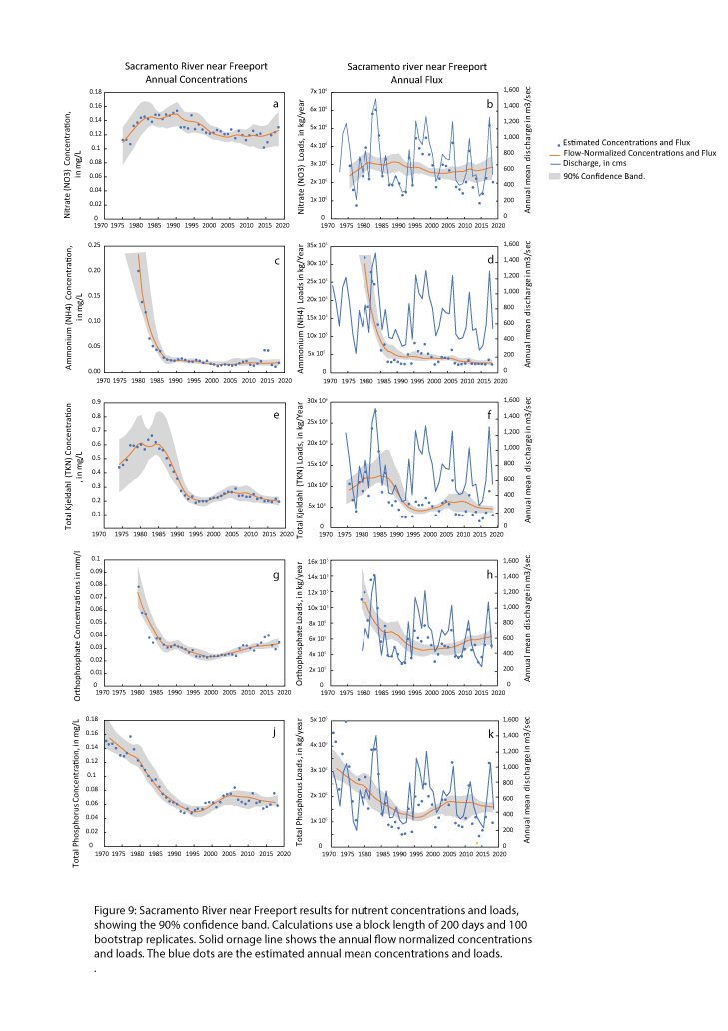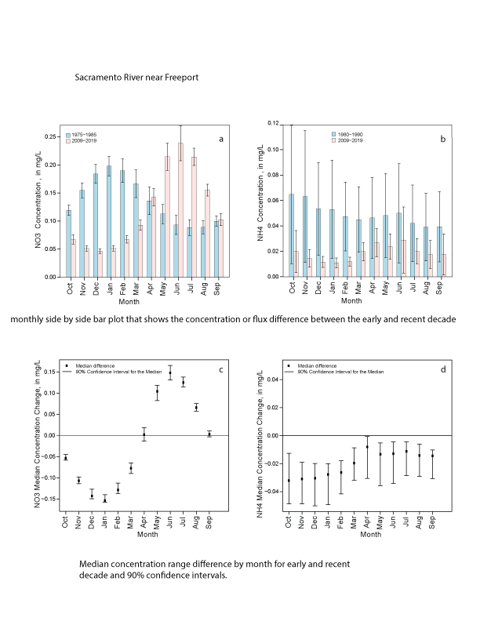

## **San Joaquin River near Vernalis**

Results of the WRTDS model are shown in figure 11. Flow-normalized NO3 concentrations varied with in the 1970-2019 period and were greatly affected by high variability in discharge (Figure 11a). This is reflected in the low concentrations due to flushing or dilution during extrema wet years like 1983 where NO3 concentrations were at there lowest value of 0.4 mg/L with flow measured at a high record of 600 cms. Results of the EGRITci test showing a “likely” decrees in concentration (about 0.14 mg/l) and loads (about 0.27 million kg/Year) over the 1970-2019 period (Table 1). Figures 11a and 11b show that the width of the 90% confidence band was relatively the same throughout the 1970-2019 period. On the other hand; many of the individual yearly estimates (shown as the blue dots) in these figures lie outside the confidence band. This due to the variability of discharge during the time period. Results of the Mann-Whitney-Wilcoxon Rank Sum test show that in the early decade NO3 concentrations were highest in the winter, this corresponds with extreme weather conditions. On the other hand, concentrations are highest during the summer in the recent decade (fig 12a). Hover median concentrations difference between the early and recent decade are only significant in the months of February and July through September (fig 12c).

Estimated annual concentrations and loads for ammonium NH4 show a different pattern than that of NO3 (figs 11c and 11d). Results show great variation in concentrations during the early time period 1975-1985 and for loads during 1985-1995 time period due to extreme variability in data. This is reflected with the wide 90% confidence band around both time periods and the fact that most of the individual yearly estimates in these figures lie outside the confidence band. The NH4 concentrations decline greatly starting in 1995 however, variation in concentrations seam to be minimal as reflected by the thin confidence band showed in figure 11c. Variation in estimated loads remain similar throughout the 1970-2019 period (fig 11d).

Results of the EGRITci test showing a “highly likely” decrees in both concentration (about 0.11 mg/l) and loads (about 0.26 million kg/Year) over the 1970-2019 period (Table 1).

Results from the Mann-Whitney-Wilcoxon Rank Sum test show that NH4 concentrations decrees greatly in the recent decade this could be caused by the City of Stockton WWTP facility upgrades that took place in 2006. Unlike NO3; the difference between the early and recent decade in NH4 concentrations are significant for all months of the year, with high NH4 concentrations in winter for the early decade and in summer for the recent decade (fig 12d).

TKN concentrations and loads decreased continuously throughout the 1970-2019 period with a larger vernation in the early decade reflected in the wide 90% confidence band (Fig 11e, and 11f). This variation is more significant for loads, where results of the EGRITci test show most individual load estimates lie outside the 90% confidence band. Results from the EGRITci test also show that there is a “highly likely” decrease in TKN concentrations (about 0.78 mg/l) and a “very likely” decrease in loads (about 2.86 million kg/year) over the 1970-2019 period ((Table 1). Trends in Op concentrations and loads fallowed a similar pattern over the 1970-2019 period. Results from the EGRITci test showed a weak “likely” decline in both concentrations and loads for the 1970-2019 period (about 0.01 mg/l in concentrations and 0.05 million kg/year in loads). EGRITci test results also showed a greater variation in estimated annual OP loads reflected in that most of the observation call outside the 90% confident band (fig 11g and 11h).

Trends in TP concentration and loads fallow a similar pattern to that of OP with a greater variation in TP concentrations in the mid-80s reflected in the wide 90% confidence band (fig 11j). TP concentrations increased in the early decade to reach its highest value of 0.29 mg/l in 1988 fallowed by a continuance decrease in concentration though the remainder of the time period. Overall results from the EGRITci test show that there is a weak “highly likely” decline in TP concentrations about 0.09 mg/L and in loads about 0.16 million kg/year over the 1970-2019 period.

Nutrient ratios (molar) in

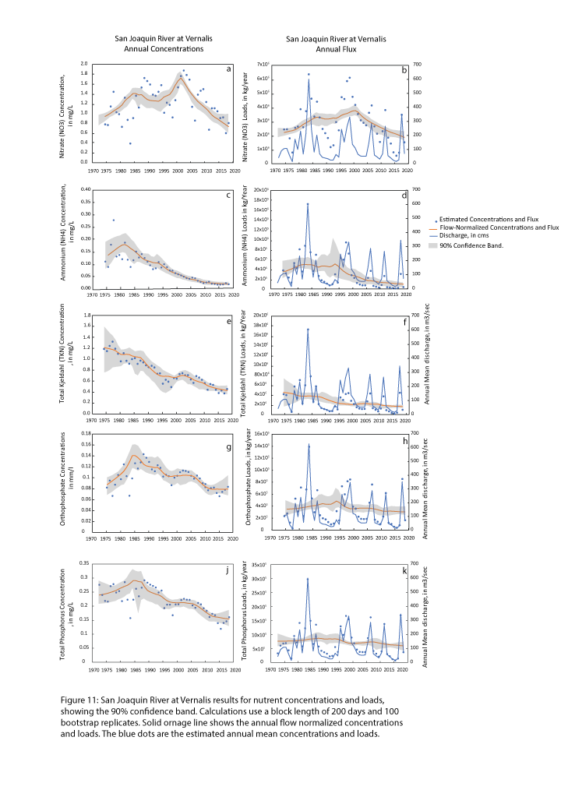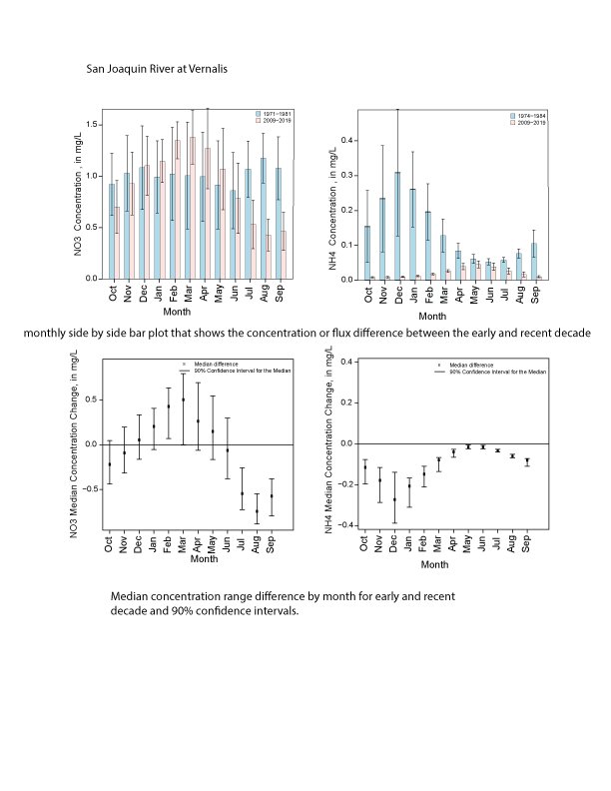

# **Discussion**

## Future planed upgrades:

The Central Valley Regional Water Quality Control Board (Central Valley Water Board)

Drinking Water Policy (DWP) Workgroup is responsible for developing a DWP for surface

waters of the Central Valley. The DWP Workgroup commissioned a study to provide an

evaluation of the current and predicted 2030 loads for drinking water constituents of concern that are discharged by Publicly Owned Treatment Works (POTWs) within the Sacramento River, San Joaquin River and tributary watersheds to the Sacramento San Joaquin River Delta (Delta).

Elevated NH4 concentrations negatively impact food webs in the Delta. Studies show that changes in nutrient ratios and forms of N are exerting additional bottom-up pressures on the Delta food webs by altering the phytoplankton community composition and the N:P composition of individual cells, and NH4 concentrations observed in areas of the Delta and the Sacramento River can exert chronic toxicity on important food sources (The et al., 2011)

# **References**

Alexander, R.B., R.A. Smith, G.E. Schwarz, E.W. Boyer, J.V. Nolan, and J.W. Brakebill, 2008. Differences in Phosphorus and Nitrogen Delivery to the Gulf of Mexico from the Mississippi River Basin. Journal of Environmental Science and Technology 42(3):822-830.

Domagalski, Joseph and Dina Saleh, 2015. Sources and Transport of Phosphorus to Rivers in California and Adjacent States, U.S., as Determined by SPARROW Modeling. Journal of the American Water Resources Association (JAWRA) 1-24. DOI: 10.1111/1752-1688.12326.

Hirsch, RM, Archifield, SA, De Cicco LD. 2015. A bootstrap method for estimating uncertainty of water quality trends. Environ Modell Softw 73:148–166 doi:<http://dx.doi.org/10.1016/j.envsoft.2015.07.017>.

Hirsch RM, Moyer DL, Archfield SA. 2010. Weighted regressions on time, discharge, and season (WRTDS), with an application to Chesapeake Bay river inputs: J Am Water Resour Assoc 46:857–880. doi: http://dx.doi.org/10.1111/j.1752-1688.2010.00482.x

Jassby, A.D., J.E. Cloern, and B.E. Cole, 2002. Annual Primary Production: Patterns and Mechanisms of Change in a Nutrient-Rich Tidal Ecosystem. Limnology and Oceanography 47(3):698-712.

Jassby, A.D. and Cloern, J.E. 2000. Organic Matter Sources and Rehabilitation of the Sacramento-San Joaquin Delta (California, USA). Aquatic Conservation: Marine and Freshwater Ecosystems 10:323-352.

Kratzer, C.R., Kent, R.H., Saleh, D.K., Knifong, D.L., Dileanis, P.D., and Orlando, J.L., 2011, Trends in nutrient concentrations, loads, and yields in streams in the Sacramento, San Joaquin, and Santa Ana Basins, California, 1975–2004: U.S. Geological Survey Scientific Investigations Report 2010-5228, 112 pp.

Krich-Brinton, A., 2017. Projected Nutrient Load Reductions to the Sacramento-San Joaquin Delta Associated with Changes at Four POTWs. Larry Walker Associates, Memorandum.

Krich-Brinton, A., J. Sager, M. Trouchon, and R. Warren, 2012. Technical Evaluation of a Variance Policy and Interim Salinity Program for the Central Valley Region. Larry Walker Associates, Memorandum.

Novick, E., R. Holleman, T. Jabusch, J. Sun, P. Trowbridge, D. Senn, M. Guerin, C. Kendall, M. Young, and S. Peek, 2015, Characterizing and Quantifying Nutrient Sources, Sinks and Transformations in the Delta: Synthesis, Modeling and Recommendations for Monitoring, December 2015, San Francisco Estuary Institute.

Preston, S.D., R.B. Alexander, G.E. Schwarz, and C.G. Crawford, 2011a. Factors Affecting Stream Nutrient Loads: A Synthesis of Regional SPARROW Model Results for the Continental United States. Journal of the American Water Resources Association 47(5):891-915, doi: 10.1111 ⁄ j.1752-1688.2011.00577.x.

Preston, S.D., R.B. Alexander, M.D. Woodside, and P.A. Hamilton, 2009. SPARROW MODELING – Enhancing Understanding of the Nation’s Water Quality. U.S. Geological Survey Fact Sheet 2009-3019, 6 pp. http://pubs.usgs.gov/fs/2009/3019/, accessed

Saleh, Dina and Joseph Domagalski, 2015. SPARROW Modeling of Nitrogen Sources and Transport in Rivers and Streams of California and Adjacent States, U.S. Journal of the American Water Resources Association (JAWRA) 1-21. DOI: 10.1111/1752-1688.12325.

Schwarz, G.E., A.B. Hoos, R.B. Alexander, and R.A. Smith, 2006. The SPARROW Surface Water-Quality Model—Theory, Applications and User Documentation. U.S. Geological Survey Techniques and Methods, book 6, chap. B3, 248 pp. and CD-ROM.

Templin, W.E. and D. E. Cherry, 1997. Drainage-Return, Surface-Water Withdrawal, and Land-Use Data for the Sacramento–San Joaquin Delta, with Emphasis on Twitchell Island, California. U.S. Geological Survey Open-File Report 97-350, 31 pp.

Western Regional Climate Center <http://www.wrcc.dri.edu/cg-bin/cliMONtpre.pl?ca7630>

Yost (West Yost Associates) (2011). Wastewater Control Measures Study.

http://www.waterboards.ca.gov/centralvalley/water_issues/drinking_water_policy/dwp_wastewtr_cntrl_meas_stdy.pdf